**An interactive tool for supporting university timetabling**

Daniela Tomás1

Department of Computer Science, Faculty of Sciences of the University of Porto, Porto, Portugal1

____________________________________________________

**Background & Aim:** University Course Timetabling Problem (UCTTP) is a combinatorial optimization problem that consists of allocating events, rooms, lecturers, and students to weekly schedules while meeting certain constraints. Due to the size and complexity of the problem, obtaining an optimal solution in usable time is not always feasible. However, using heuristic algorithms, it is possible to get approximate and good-quality solutions efficiently.

The process of building timetables at FCUP each semester is time-consuming, not automated, and the results are not the most satisfactory. In general, the currently available tools focus primarily on visualizing timetables or on basic conflict detection without offering optimized solutions.

Therefore, the main objective is to improve the efficiency and quality of FCUP's weekly timetable development by providing step-by-step interactive recommendations and detecting potential conflicts during its construction. This functionality must be integrated into a timetable visualization interface that was previously developed using reactive programming.

**Methods:** The Monte Carlo Tree Search (MCTS) heuristic search algorithm was chosen to construct the timetables, as it has been applied to various optimization problems and has proven to be particularly effective in games. Although it has shown positive results in various areas, in the context of UCTTP there are no studies that use MCTS. Each phase of the MCTS algorithm is shown in Figure 1, where *E* represents the events to be scheduled, *P* the periods consisting of a day and a timeslot, and *R* the rooms. Hill Climbing (HC) was also chosen to be used in conjunction with MCTS in the simulation phase for local optimization.

To get an idea of how the algorithm is performing, the benchmark datasets from the International Timetabling Competition 2007 track 3 [1] are being used.

**Results:** Both algorithms have been implemented, and they find a feasible solution for all instances. However, the algorithms can still be refined to achieve better results.

**Conclusions:** The proposed system presents a novel application of MCTS to UCTTP, combined with HC for local improvements. By leveraging interactive recommendations and conflict detection, the tool provides a more efficient and adaptive scheduling process for FCUP and can be extended to other institutions and help in other studies. Future work will focus on refining the heuristic functions, improving computational performance, and integrating the visualization interface previously developed.

**Keywords:** University Course Timetabling Problem; Monte Carlo Tree Search; Hill Climbing

**Acknowledgments:**

I’d like to acknowledge my supervisor, João Pedro Pedroso, for his guidance and support.

**References:**

[1] *International Timetabling Competition --- eeecs.qub.ac.uk.*<https://www.eeecs.qub.ac.uk/itc2007/Login/SecretPage.php>

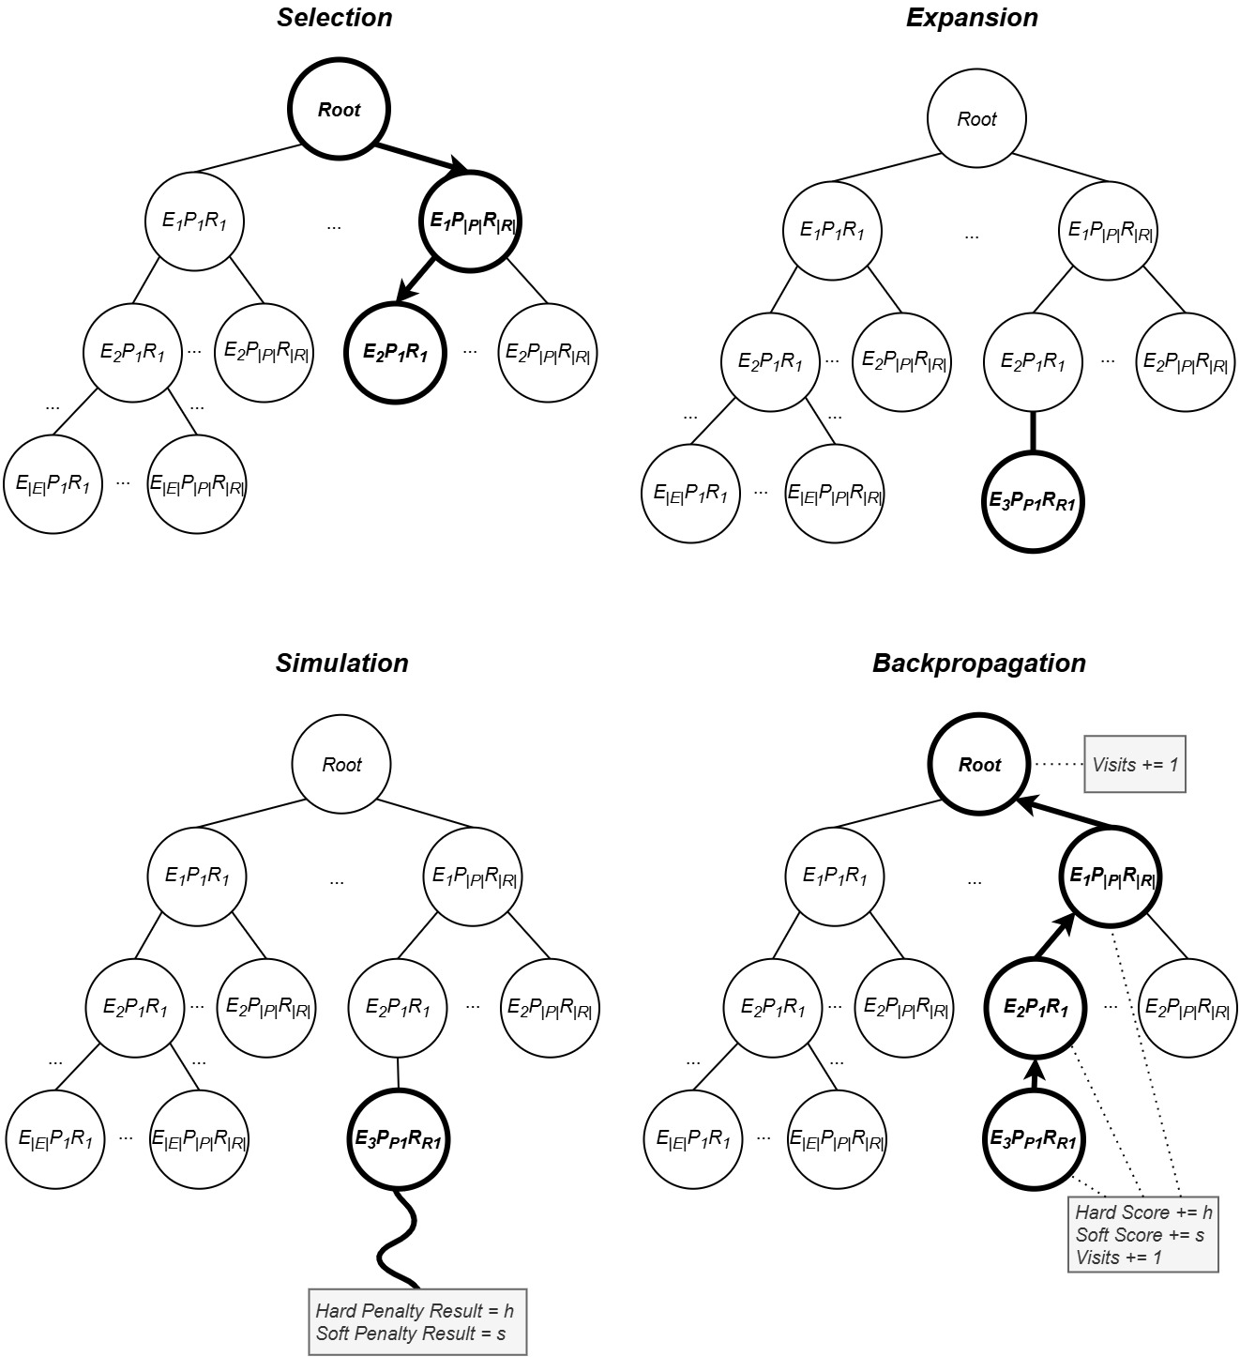

**Figure 1**: Monte Carlo Tree Search steps